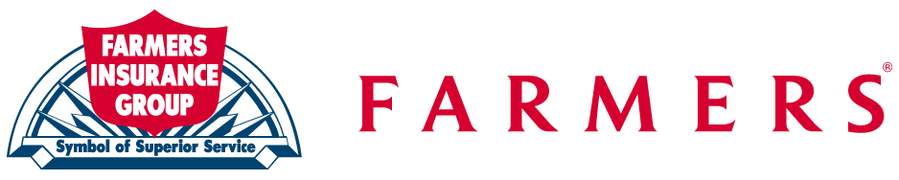
National Catastrophe Center of Excellence
P.O. Box 2968
Shawnee Mission, KS 66201-1368
Phone: 1 (888) 344-4343
FAX: 1 (800) 421-8978

Dear Farmers Insurance Policyholder:

Farmers Insurance and its National Catastrophe Center are proud to announce a new claims initiative. The Farmers First Choice Repair Program has been developed to assist our customers with roofing, siding, and gutter damage as a result of covered claims. The Farmers First Choice Program utilizes specialized contractor networks to provide credentialed contractors to meet your needs.
Triage Management Services is the managing Third Party Administrator who can assist you in the event you choose to utilize the Farmers First Choice Repair Program. In the event you should need to contact them they can be reached at (800) 587-4243.

The claims process is simplified by having reputable and credentialed contractors provide estimates and repairs for you, our customer! The process is as follows:

- A Farmers Insurance claims adjuster will inspect your home, if this has already not been done. If the inspection reveals covered roofing, siding, or gutter damages, then we will have a representative from Triage contact you.

- If you wish, you may use Triage to fulfill the repairs to your home, or you may choose to locate your own roofing contractor.

- If you choose to use Triage, they will arrange for a certified contractor to visit your home to complete an inspection, verify damages, and provide an estimate bid for completion of the covered repairs as well as any upgrades that you may select.

- At this time, if you wish, you may enter into a contract to have the repairs to your home completed by Triage.

Note: Triage can also assist you with emergency tarping and window board ups.
Give Triage a call for assistance!

This program will provide the following benefits:

  - Professional workmanship from certified contractors
  - Contractors committed to Farmers customers satisfaction
  - Extended 5-year limited labor warranty
  - Performance management to ensure quick and timely repairs
  - Customer service center to answer questions and resolve any problems
  - Field experts to monitor contractor repair and installation quality

Triage Management Services
(800) 587-4243

Claims Department
National Catastrophe Center

